**Assignment 3 - User input- Instructions**

LIU Qianwei 24061259g

This is a Halloween-themed whack-a-mole game using Pygame, called “Kill the Pumpkin.” After clicking the “Start” button, the game will begin. In the next 15 seconds, pumpkins and demon claws will appear randomly. Clicking on the pumpkins will earn you points, while clicking on the demon claws will deduct points. Once the game is over, your score will be displayed, and a “Restart” button will be provided to allow you to play again.

* 1. Click the start button to start the game

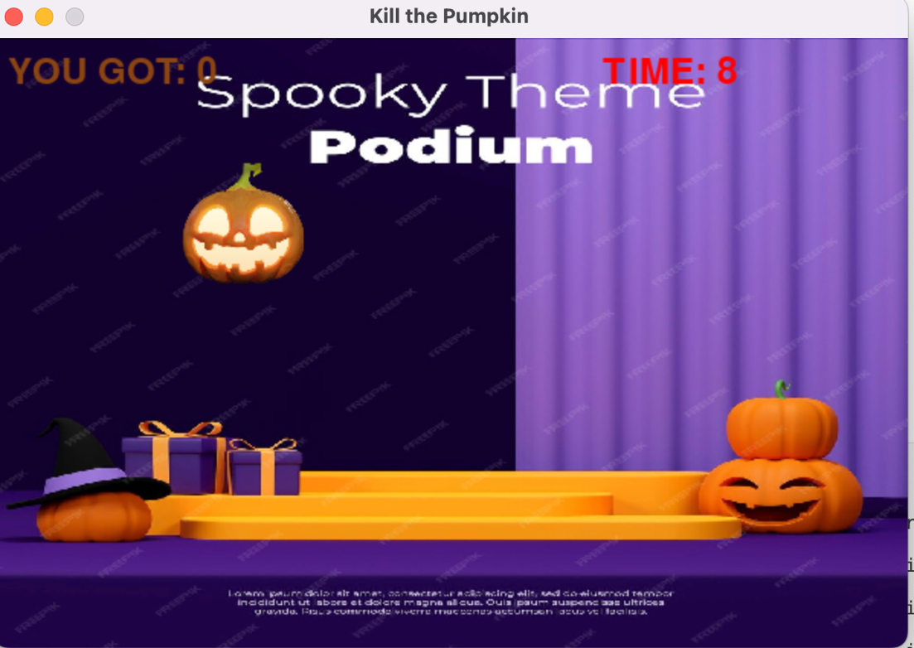

* 1. The top left corner displays the real-time score, while the top right corner shows the countdown. Successfully clicking on a pumpkin earns you +1 point.

* 1. Clicking on the green demon claw deducts 1 point.

1.4 Congratulations screen: This screen displays your final score. If you want to play again, click the “Restart” button.